University of Ibadan
Computer Science Department
B.Sc. Degree Examination
First Semester Examinations (2022/2023 Session)
CSC 321: Computer Operating Systems

Answer Question 1 and any other 2 Questions Time Allowed: 2 Hours

Question 1. (30 marks)
- With 4 suitable phrases, define an operating system. (4 marks)

    - An operating system acts as an intermediary between the user of a computer and computer hardware. The purpose of an operating system is to provide an environment in which a user can execute programs in a convenient and efficient manner.
    - An operating system is a program that controls the execution of application programs and acts as an interface between the user of a computer and the computer hardware.
    - An operating system is a set of special programs that run on a computer system that allows it to work properly.
    - A more common definition is that the operating system is the one program running at all times on the computer (usually called the kernel), with all else being application programs.
    - An operating systems provide a set of functions needed and used by most applications, and provide the necessary linkages to control a computer's hardware.

- Compare and contrast static or fixed partitions memory allocation scheme with dynamic partitions memory scheme. (6 marks)
In static or fixed partitions memory allocation scheme, the memory was divided into several partitions. The aim was to accommodate more than one process in the memory at any given time, thereby supporting multi-programming. These partition could be of the same size or of different sizes. Because the size of each partition was designated when the system was powered on, each partition could only be reconfigured when the computer system was shut down, reconfigured.  It caused internal fragmentation | The idea of a variable-size partition allows the operating system to create partitions of exactly the right size for a particular process wherever there is sufficient space available. That is to say that each time a process needed memory to be executed, the exact size it needs is ‘carved out’ and allocated to it. This then eliminates internal fragmentation, but a new problem emerges, External fragmentation

- A uniprocessor system has jobs accepted as shown in the information below:
Job No | Arrival time | CPU time | Waiting time | Start time | Finish time | Turnaround time
Job 1 | 10:00am | 30 mins
Job 2 | 10:05am | 1hr 25mins
Job 3 | 10:10am | 25 mins
Job 4 | 10:15am | 15 mins
Job 5 | 10:20am | 10 mins
Copy and complete the table for the following scheduling algorithms
  - FCFS (5 marks)
  - Shortest Job Next (5 marks)

- With a suitable diagram, briefly discuss the layered OS architecture. (4 marks)
As operating systems became larger and more complex, this approach was largely abandoned in favour of a modular approach which grouped components with similar functionality into layers to help operating system designers to manage the complexity of the system. In this kind of architecture, each layer communicates only with the layers immediately above and below it, and lower-level layers provide services to higher-level ones using an interface that hides their implementation.
The modularity of layered operating systems allows the implementation of each layer to be modified without requiring any modification to adjacent layers. Although this modular approach imposes structure and consistency on the operating system, simplifying debugging and modification, a service request from a user process may pass through many layers of system software before it is serviced and performance compares unfavourably to that of a monolithic kernel. Also, because all layers still have unrestricted access to the system, the kernel is still susceptible to errant or malicious code. Many of today’s operating systems, including Microsoft Windows and Linux, implement some level of layering.

- Processor Management involves activities of the Job scheduler, Process Scheduler and interrupt scheduler. What are the main functions of these three schedulers? (3 marks)
Answer:
Processor Management is treated extensively in a study session. It consists of the Job Scheduler (also called the high-level scheduler):- which creates jobs out of user requests to the Operating System, admits the jobs and put them on the ready queue. The Process Scheduler (also called the low-level scheduler):- .that picks a job from the ready queue and assigns the processor to that job. The Interrupt scheduler:- which handles the interrupts of processes. Note that the Job scheduler works in a multi-programming environment because in a uni-programming environment, only ONE job/ process is running at any given time.

- There are two types of user-interfaces used with the computer system. Of the two, the graphical user interface (GUI) is the most popular user interface today. Briefly discuss the GUI. (3 marks)
Answer:
A GUI uses windows, menus and icons to execute commands. A mouse is the most common way to navigate through a GUI, although many GUIs allow navigation and execution via a keyboard. GUI based operating Systems are Windows 7, 8, 10, MacOS, Android, IOS. Windows are the workspaces inside which each application runs, and can typically be resized, moved around, and hidden as required by the user. Icons are small images that are used as shortcuts, to open applications, files or directories. A menu contains a short list of functions, allowing the user to easily select the task they wish to perform. Pointers are moveable images, controlled by a pointing device such as a mouse, that allow the user to track their position on the screen and to select windows, icons or menu items at the click of a button.
Question 2 (15 marks)
- Distinguish between a preemptive scheduling policy and a non-preemptive scheduling policy (4 marks)
There are 2 classes of scheduling algorithms: Preemptive Scheduling algorithms and Non-Preemptive Scheduling algorithms. A scheduling algorithm that interrupts the processing of a job and transfers the CPU to another job is called a preemptive scheduling policy; it is widely used in time-sharing environments. Here the processor can be forced to stop executing a process, even if the process has not run to completion. A non-preemptive scheduling policy on the other hand, functions without external interrupts (interrupts external to the job). Here, the processor cannot be forced to stop executing a process. So the process monopolizes the processor and runs to completion, except if the process makes an I/O request (this is called a natural wait) or there is an infinite loop which the system will interrupt.

- Compare and contrast an Operating System with a Kernel (6 marks)
OPERATING SYSTEM | KERNEL
Operating System is a system software. | Kernel is system software which is part of operating system.
It is the first program to load when a computer/ phone/ tablet boots up. | It is the first program to load when operating system loads.
Operating System provides interface between user and the hardware. | Kernel provides interface between application and hardware.
It also provides protection and security. | It’s main purpose is memory management, disk management, process management and task management.
All system needs operating system to run. | All operating system needs kernel to run.
Types of operating system include:- single and multiuser, multiprocessor, realtime, distributed. | Types of kernel include: Monolithic, Micro kernel, Hybrid, Nano.

Why was it necessary for multi-programming environment to introduce some form of scheduling policies? Discuss any five reasons. (5 marks)
- Maximize throughput. Run as many jobs as possible in a given amount of time. This could be accomplished easily by running only short jobs or by running jobs without interruptions.
- Minimize response time. Quickly turn around interactive requests. This could be done by running only interactive jobs and letting the batch jobs wait until the interactive load ceases.
- Minimize turnaround time. Move entire jobs in and out of the system quickly. This could be done by running all batch jobs first (because batch jobs can be grouped to run more efficiently than interactive jobs).
- Minimize waiting time. Move jobs out of the READY queue as quickly as possible. This could only be done by reducing the number of users allowed on the system so the CPU would be available immediately whenever a job entered the READY queue.
- Maximize CPU efficiency. Keep the CPU busy 100 percent of the time. This could be done by running only CPU-bound jobs (and not I/O-bound jobs).
- Ensure fairness for all jobs. Give everyone an equal amount of CPU and I/O time. This could be done by not giving special treatment to any job, regardless of its processing characteristics or priority.
- Avoid indefinite postponement. This can be achieved by allowing processing to age.

Question 3 (15 marks)
- Operating Systems have evolved over the years, ranging from Single-user Operating System to Multi-user operating system and from Single-tasking Operating System to Multi-tasking Operating System. What do these phrases imply? Given an example for each category. (6 marks)
Single-user Operating System is designed to manage the computer so that one user can effectively use the system at any point in time e.g. MS DOS. A multi-user operating system allows many different users to take advantage of the computer's resources simultaneously (Windows NT). The operating system must make sure that the requirements of the various users are balanced. Single-tasking Operating System allows only one job to be executed at a time, e.g MS-DOS. They are usually also single-user. Multi-tasking Operating System - This is the type of operating system most people use on their desktop and laptop computers today. Microsoft's Windows and Apple's MacOS platforms are both examples of operating systems that will let a single user have several programs in operation at the same time. For example, it's entirely possible for a Windows user to be writing a note in a word processor while downloading a file from the Internet while printing the text of an e-mail message. .
- Briefly describe the memory allocation scheme that was first developed to eliminate the problem of fragmentation.(5 marks)
Dynamic Partitions
The idea of a variable-size partition allows the operating system to create partitions of exactly the right size for a particular process wherever there is sufficient space available. That is to say that each time a process needed memory to be executed, the exact size it needs is ‘carved out’ and allocated to it. This then eliminates internal fragmentation, but a new problem emerges. Processes are initially added to the system using contiguous memory space (Figure 9.5). However, as each process completes, it is removed from the system leaving a ‘hole’ in memory. This hole can be used for a new process, providing the new process will fit into the space made available. Since it highly unlikely that any new processes will fit exactly into the gaps left by the old processes, the only processes able to use these gaps in memory will be smaller than their predecessors.
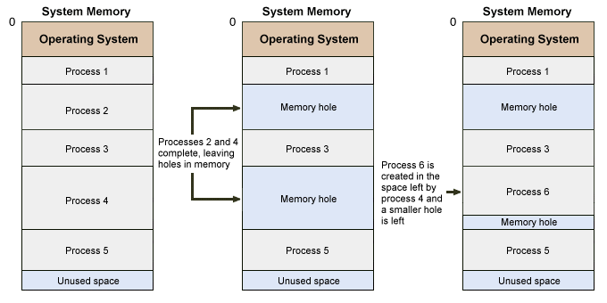

- When does a process make a system call? What happens thereafter? (4 marks)
A request for I/O from a user process is signalled to the operating system using a system call (sometimes called a software interrupt). When a process makes a system call, it effectively hands control of the processor back to the operating system to enable it to service the request. Even the operating system itself does not talk directly to hardware devices, however. It will instead pass the request on to the appropriate device driver.
Question 4 (15 marks)

- What are the four major categories of benefits to multi-threading, especially in a uniprocessor? (4 marks)
There are four major categories of benefits to multi-threading:
  - Responsiveness - One thread may provide rapid response while other threads are blocked or slowed down doing intensive calculations.
  - Resource sharing - By default threads share common code, data, and other resources, which allows multiple tasks to be performed simultaneously in a single address space.
  - Economy - Creating and managing threads ( and context switches between them ) is much faster than performing the same tasks for processes.
  - Scalability - Utilization of multiprocessor architectures - A single threaded process can only run on one CPU, no matter how many CPUs may be available, whereas the execution of a multi-threaded application may be split amongst available processors.

- Sketch a well labelled and annotated figure of the five-state process state diagram. (3 marks)
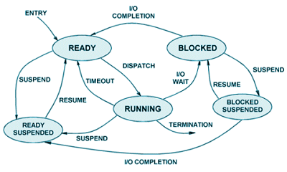
A five-state process state diagram
- The Unix Operating System has some unique features and symbols. What is the usefulness of the following in the Unix operating system environment? (3 marks)
  - Pipe ii. Filter iii. >>

The Unix pipe symbol is used on the command line. Pipe is used to combine two or more commands, and in this, the output of one command acts as input to another command
Filters allow you to manipulate data. A filter is a Unix command that does some manipulation of the text of a file. When a program takes its input from another program, performs some operation on that input, and writes the result to the standard output (which may be piped to yet another program), it is referred to as a filter
If a command is executed using the >> symbol, the output gets written to a file

- Using suitable diagrams juxtapose between internal and external fragmentation. (7 marks)

External fragmentation is a situation in which the dynamic allocation of memory creates unusable fragments of free memory between blocks of busy, or allocated, memory.  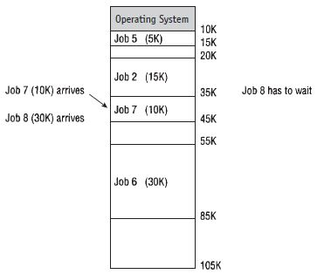 | Internal fragmentation is a situation in which a fixed partition is only partially used by the program; the remaining space within the partition is unavailable to any other job and is therefore wasted.  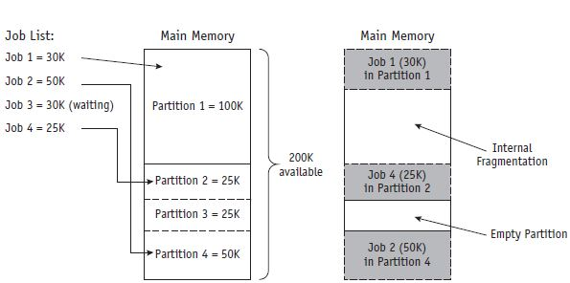

Question 5 (15 marks)
- A Graphic Designer Tamilore organized a competition for some students, where he asked them to draw any scene/ object of their choice on a piece of paper and bring along to be submitted the following day. On the day of submission, Tamilore the graphic designer provided a large wall that he divided into sections of different sizes. For each student to prove that he/she had done the drawing by himself/herself, the student was expected to redraw the drawing in any suitable section of their choice on the wall! The drawing must also be drawn at the same scale as the one on their paper. Unfortunately, some students’ drawing could not completely fit into any section while some other students’ drawing did not completely cover the chosen section. If any drawing could not completely fit into any section, the student would not be allowed to draw on the wall.
- Using your knowledge of Memory management, which computer term would you give each to the drawing and the wall? (2 marks) Drawing = Jobs , Wall = Memory
- From your understanding, what memory allocation scheme do your think the artist implemented? Describe this scheme in O/S terms. (4 marks)
Ans: The scheme is fixed partitions: a memory allocation scheme in which main memory is sectioned off, with portions assigned to each user. Also called static partitions.
- What term could be used to describe the phenomenon described by the underlined phrase? (2 marks) Ans: Internal fragmentation

- What is Context Switching? When can it be performed by a non-preemptive scheduling algorithm? (4 marks)
All preemptive algorithms must perform Context Switching. When Job A is pre-empted for Job B, all Job A’s processing information must be saved in it’s PCB for a later time, when Job A’s execution is to be continued. Then the content of Job B’s PCB are loaded into the appropriate registers so it can start running. This is CONTEXT SWITCHING. A non-preemptive scheduling policy can only perform context switching when a running process makes an I/O request (this is called a natural wait)

- How are priorities assigned to jobs? (3 marks)
If the processor manager is to determine the priority of the process, then some of these characteristics are considered:
- The memory requirements of the process. If a process needs high memory requirement, then a low priority will be assigned
- The total CPU time. Long CPU time means low priority
- Waiting Time: longer waiting time means higher priority. Note this is called aging.

